
ASSIGNMENT COVER SHEET
PROGRAMME | : | Bachelor of Business Analytics (Hons)
SUBJECT CODE AND TITLE | : | SIS3044 Sustainable Information System
ASSIGNMENT TITLE | : | Final Assessment
LECTURER | : | Dr Narishah & Madam Azura | ASSIGNMENT DUE DATE: | 05/01/2026

STUDENT’S DECLARATION
- I hereby declare that this assignment is based on my own work except where acknowledgement of sources is made.
- I also declare that this work has not been previously submitted or concurrently submitted for any other courses in Sunway University/College or other institutions.
[ Submit “Turn-it-in” report (please tick √): Yes _____ No _____ ]

NO. | NAME | STUDENT ID NO. | SIGNATURE | DATE
1. | Yaw Chin Hen | 21058417 | ChinHen | 30/12/2025
2. | Yang Ka Weng | 21095872 | Ykw | 30/12/2025
3. | Tam Sze Yin | 21093893 | Sam | 30/12/2025
4.
5.
6.

E-mail Address / Addresses (according to the order of names above):
1. 21058417@imail.sunway.edu.my | 4.
2. 21095872@imail.sunway.edu.my | 5.
3. 21093893@Imail.sunway.edu.my | 6.

APPROVAL FOR LATE SUBMISSION OF ASSIGNMENT (If applicable)
IF extension is granted, what is the revised due date? ______________________________________________

Signature of Lecturer: ______________________________________ Date: ____________________________

Marker’s Comments:

Marks and / or Grade Awarded: _____________________________ Date:____________________________
ADDENDUM

USE OF ARTIFICAL INTELLIGENCE (A.I.) DECLARATION
Students are allowed to use AI to support completion of assessments. However, students are reminded to do so ethically and transparently. This is so that (a) submissions can be fairly and accurately marked; and (b) feedback can be provided on the content that reflects student ability, in order to help with future submissions. Students are also reminded that in accordance with the University’s Academic Malpractice Policy, Item 4.11.2, “… the representation of work: written, visual, practical or otherwise, of any other person, including another student or anonymous web-based material [emphasis added], or any institution, as the candidate’s own” is considered malpractice.

Declaration
[ / ] I / We used the following A.I. tools to produce content in this submission:
Tool | Purpose | Prompts | Sections where AI output was used / Outcome(s) in the submission
Grammarly | Correcting grammar and spelling, improving sentence structure | N/A | Grammarly suggestions were used for all sections of the essay
Note: Add additional rows if necessary.

OR

[ ] I / We did not use any A.I. tools to produce any of the content in this submission.

NO. | NAME | STUDENT ID NO. | SIGNATURE | DATE
1. | Yaw Chin Hen | 21058417 | ChinHen | 30/12/2025
2. | Yang Ka Weng | 21095872 | Ykw | 30/12/2025
3. | Tam Sze Yin | 21093893 | Sam | 30/12/2025
4.
5.
6.

E-mail Address / Addresses (according to the order of names above):
1. 21058417@imail.sunway.edu.my | 4.
2. 21095872@imail.sunway.edu.my | 5.
3. 21093893@Imail.sunway.edu.my | 6.

Table of Contents
Abstract 5
1. Introduction 5
1.1 Project Background 5
1.2 Problem Statement 6
1.3 Project Objectives 6
1.4 Project Scope 6
2. Literature Review 6
2.1 Conventional Performance Appraisal and Subjectivity 6
2.2 SMART Key Performance Indicators of Performance Management 7
2.3 Human Resource Analytics and Machine Learning 7
2.4 XGBoost Non-Linear Performance Prediction. 7
2.5 Research Gap 8
3. Project Methodology 8
3.1 Methodological Overview 8
3.2 Machine Learning Development with CRISP-DM 8
3.2.1 Business Understanding 8
3.2.2 Data Understanding 8
3.2.3 Data Preparation 8
3.2.4 Modeling 8
3.2.5 Evaluation 9
3.2.6 Deployment 9
3.3 System Development through Iterative Prototyping 9
3.4 CRISP-DM and Iterative Prototyping Integration 9
4. System Design and Web/Machine Learning Integration 10
4.1 Overall System Architecture 10
4.1.1 User Interface and Data Input Layer 10
4.1.2 Machine Learning and Backend Layer 10
4.1.3 Dashboard and Visualization Layer 10
4.2 Machine Learning Integration through FastAPI 10
4.3 Dashboard Design and Technical Tools 11
4.3.1 Dashboard Features 11
4.3.2 Technical Tools Used 11
5. Model Development and Evaluation 11
5.1 Justification of the Model Selection 11
5.1.1 Why XGBoost 11
5.1.2 Processing Non-Linear SMART KPI Data 12
5.2 Model Training Process 12
5.3 Model Evaluation Metrics 12
5.4 System Integration and Discussion 14
6. ESG and Sustainable Impact 14
6.1 Environmental (E) 14
6.2 Social (S) 14
6.3 Governance (G) 14
6.4. Conformity to United Nations Sustainable Development Goals (UN SDGs) 14
7. Limitations and Future Enhancement 15
8. Conclusion 15
References 15

SmartAppraise AI: Predictive Modeling for Employee Performance Appraisal Using SMART Data and Non-Linear Feature Analysis
Yaw Chin Hen 21058417, Tam Sze Yin 21093893, Yang Ka Weng 21095872

Abstract
Performance appraisal is very important in human resource management, as it determines promotion, compensation, and workforce planning decisions. Conventionally, performance reviews were based on subjective decisions that were normally ineffective and inconsistent. In order to solve these problems, companies have implemented SMART Key Performance Indicators (KPIs) to make evaluations standardized. Nevertheless, the SMART KPI metrics pose new difficulties, since the performance indicators in relation to employees are frequently non-linear, and weakly correlated, as well as hard to analyze through the traditional tools.
This project suggests SmartAppraise AI, which is a performance appraisal system based on data and is developed using non-linear machine learning strategies that objectively forecast worker performance classes. Based on the SMART KPI data, the system uses XGBoost multi-class classification model to include the complex interaction of the features and enhance predictive accuracy. The model is tested based on the accuracy, ROC-AUC, confusion matrix, and training-validation loss analysis.
To make the predictive model more practical to use, it will be incorporated into a web-based dashboard in which HR professionals could see the results and assist in making data-driven decisions. The project shows how non-linear feature analytics can enhance fairness, transparency, and efficiency in the contemporary performance appraisal systems, besides serving as a contributor to the Environmental, Social, and Governance (ESG) goals.
Keywords: Employee Performance Appraisal, SMART KPIs, XGBoost, Machine Learning, FastAPI, HR Analytics, Multi-Class Classification, Sustainable Human Resource Management

1. Introduction

1.1 Project Background
Employee performance appraisal is an essential or core process in the management of the organization, as it directly influences employee development, rewarding employees, and strategic planning of the workforce. Traditionally, the performance appraisals had been done based on the judgment of managers and manual scoring methods, which most of the time resulted in subjectivity, bias, and lack of consistency in the evaluation (Shi & Van Triest, 2025). These restrictions eroded trust in appraisal systems and diminished its usefulness in facilitating organizational objectives.
Many organizations have made the use of the SMART KPI model, where the performance indicators are spelled out as Specific, Measurable, Achievable, Relevant, and Time-bound in order to enhance objectivity. Although SMART KPIs give structure and standardisation, they also create huge amounts of performance-related data. Practically, such data may be non-linear, intricate, and have low to strong or indirect correlations with the overall employee performance. Consequently, old linear analysis tools cannot be used to draw valuable information on SMART KPI datasets.
As machine learning and data analytics continue to develop, non-linear models have become a valuable tool to represent complicated shapes of high-dimensional data. When applied to human resource analytics, machine learning also has the advantage of revolutionizing the performance appraisal into a more objective, consistent, and data-driven.

1.2 Problem Statement
Although SMART KPIs are adopted, performance appraisal has been difficult because of a number of major problems. SMART KPI variables do not necessarily have a linear correlation with employee performance outcomes, and so the HR practitioners can rarely interpret results correctly. Second, manual or rule-based evaluation methods cannot properly model intricate interrelations between several performance indicators. Third, the current appraisal systems have been found to be broken in various systems that have been found to add on to the administration and diminish efficiency.
As a result, organizations need a smart system capable of processing non-linear SMART KPI data, minimize bias during the assessment of performance, and provide insights in a clear and practical way (Shields et al., 2023).

1.3 Project Objectives
The main goals of this project include:
- Train a non-linear machine learning model to predict the classes of employee performance based on SMART KPI data.
- Examine the interplay of complex features in order to enhance the objectivity and consistency of performance appraisal.
- Develop and implement a single analytics solution that combines predictive analytics with an interactive dashboard to aid human resources decision-making.

1.4 Project Scope
The current project is aimed at creating a predictive performance appraisal system based on machine learning methods. The scope encompasses data preprocessing, feature engineering, model training, evaluation, and system deployment. There is a multi-class XGBoost classifier that is used to make predictions concerning the level of employee performance, and the model is tested by using the performance metrics that are pre-existing. The actual implementation is in the form of a web-based application where users can submit data, see the predictions, and analyze the results graphically. The project focuses on analytical precision, functionality, and conformity to the principles of ESG, such as fairness, transparency, and sustainable management of the workforce.

2. Literature Review

2.1 Conventional Performance Appraisal and Subjectivity
The use of traditional performance appraisal and subjectivity has been strongly associated with two main factors in HR practice: (1) extensive subjectivity and (2) bureaucracy in the appraisal process.
Performance appraisal has been a major part of human resource management that has aided in decision-making concerning promotion, salary, and employee development. The conventional forms of appraisals were mainly based on the judgment of supervisors, rating scales, and narrative-based appraisals (Bicudo de Castro, 2017). Although these methods make the discretion of the managers possible, they are often criticized as being subjective and prone to cognitive bias, including halo effect, leniency bias, and recency bias. Consequently, performance ratings might not be a true representation of employee contributions, which results in decreased fairness and dissatisfaction of the employees (Bretz et al., 1992).
Earlier researches point out that subjective appraisal systems are not universally consistent among departments and appraisers, and thus organizations have a hard time developing consistent performance standards (Kunz, 2015). These constraints prompted organizations to search for more formal and objective performance measurement systems.

2.2 SMART Key Performance Indicators of Performance Management
To solve subjectivity, organizations started embracing SMART Key Performance Indicators (KPIs), which focus more on specificity, measurability, achievability, relevance, and time-based evaluation. The SMART KPIs are designed to convert job titles into measurable items that allow more consistent and transparent evaluation of performance (Wick, 2021).
Nonetheless, studies show that the SMART KPIs also create new analytical setups. The nature of performance among employees is multi-dimensional in nature and individual KPI variables tend to have weak, indirect or non-linear relationships with the overall performance outcome. As an example, the high attendance rates are not necessarily correlated with high productivity, and the number of hours spent on training can only add to the performance in some circumstances. In turn, the simple aggregation or linear scoring models can simplify the process of performance evaluation and overlook the presence of intricate interactions between KPIs (Tran & Järvinen, 2022).

2.3 Human Resource Analytics and Machine Learning
The introduction of a new category of data-driven procedures into HR decision-making has been facilitated by the introduction of Human Resource Analytics (HR Analytics). In particular, machine learning methods provide the capability of modeling complex patterns in high-dimensional data. Machine learning algorithms are able to obtain non-linear functions, interaction effects, and hierarchical dependencies of features as compared to the traditional statistical models (Waheed et al., 2018).
The efficacy of models applied in classifying employees to forecast their performance, attrition, and engagement has been demonstrated in previous studies. Ensemble methods, i.e., Random Forest and Gradient Boosting, based on trees, have demonstrated superiority over the linear model when the HR data is heterogeneous and non-linear (Woerkom & Kroon, 2020). The results indicate that the datasets of SMART KPI can be effectively analyzed using advanced machine learning models.

2.4 XGBoost Non-Linear Performance Prediction.
Extreme Gradient Boosting (XGBoost) is a strong ensemble learning model that constructs decision trees in a cascading manner in order to reduce the error of prediction. It is especially useful in the field of performance appraisal due to the capacity to process non-linear relationships, as well as, feature interactions and imbalanced data. Furthermore, XGBoost also allows multi-class classification by providing the option of using softmax objective function so that the performance of the employees can be estimated by considering multiple levels of performance as opposed to binary outcome (Kang & Park, 2025).
XGBoost has since been identified as having a high prediction accuracy, scalability, and strength in the field of HR related applications. Besides, it has built-in regularisation mechanisms that curb overfitting that is paramount in the event of complex SMART KPI data.

2.5 Research Gap
Whereas some studies in the past have found machine learning to be valuable in performance appraisal, most studies have only considered the accuracy of prediction but not practical implementation and explanation to HR practitioners. Additionally, scanty literature incorporates SMART KPI information, non-linear feature analysis and entire system with visualization and decision support. This project fills these gaps with the combination of non-linear predictive modeling and a dashboard-based analytics platform to help in making transparent and actionable performance appraisal possible.

3. Project Methodology

3.1 Methodological Overview
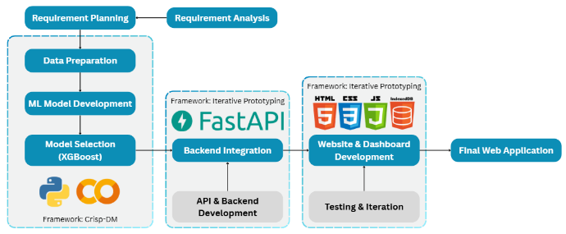
Figure 1: Project Life Cycle
The project follows a hybrid approach in methodological approach that combines the CRISP-DM framework with the Iterative Prototyping to assist with the analytics creation, as well as system implementation. The reasoning behind such a hybrid solution is based on the duality of the project, where (1) a strong machine learning model that predict employee performance and (2) the deployment of this model in an interactive web-based analytics system.
CRISP-DM will be used to design the machine learning lifecycle, which ensures the systematic definition of problems, data management, modeling, and analysis (Muhammad Fawwaz Narendra, 2025). Meanwhile, the system development is being driven by the help of Iterative Prototyping that allows one to constantly improve the user interface, system functionality, and dashboard design on the basis of the initial results. This integrated approach guarantees that the concept of analytical rigor and practical usability is considered at the same time, which leads to a trusted user-friendly HR analytics tool (Hulugh & Emmanuel, 2024).

3.2 Machine Learning Development with CRISP-DM

3.2.1 Business Understanding
The main business goal of the project is to increase the objectivity and consistency of the performance appraisal of employees using the data-driven decision-making. The conventional appraisal systems are usually based on the subjective judgment by the managers that can lead to bias and inconsistency. SmartAppraise AI aims to address such problems by forecasting the performance of employees, depending on measurable SMART KPI variables.
The problem formulation, in terms of analytics, can be stated as a multi-class classification task, in which employees will be classified into performance classes, which are predefined as: Low, Below Average, Average, Above Average, and High. These classes would conform to the HR performance evaluation practices to allow actionable insights to performance monitoring, talent development, and managerial decision-making.

3.2.2 Data Understanding
The data analysis in this project will include the variables of SMART KPI at the employee level that comprise a variety of dimensions, i.e., attendance, workload, compensation, training, and behavioral indicators. Exploratory Data Analysis (EDA) is done to get familiar with the distribution of features, find missing values, and other possible anomalies.
The analysis of class distribution is conducted to determine whether categories of performance are equal because the lack of balance of classes can affect the learning of the model. Moreover, the correlation analysis and visualization procedures demonstrate that most of the KPI variables demonstrate weak linear correlations with the performance outcomes. This observation underscores the fact that there are non-linear trends and feature interactions, which underscores the importance of developing more sophisticated machine learning models, which can exploit more complex relationships than the linear ones.

3.2.3 Data Preparation
The preparation of data is very important in the reliability and fairness of models. This stage entails data cleaning processes like missing values, duplicates, and inconsistent records. The features are scaled to numerical values through the feature scaling methods to make them stabilized in training the model.
The feature encoding is used when needed to encode the categorical variables and turn them into the numerical representations that can be used in the machine learning algorithms.
Also, the selection of SMART KPI variables is done carefully to reduce the rate of bias and fair performance evaluation. Variables that can lead to unfair advantage or discrimination, either directly or indirectly, are considered, and the model is based on job-relevant performance indicators as opposed to demographic or sensitive characteristics.

3.2.4 Modeling
Extreme Gradient Boosting (XGBoost) is the main machine learning algorithm that is used in the modeling phase. XGBoost is chosen because it is effective in its approach to non-linear relationships, feature interaction, and structured tabular data often available in the HR analytics.
Multi-class classification is deployed based on the softmax objective function, in which the model provides the likelihood of performing in more than one category. The optimization of hyperparameters is done by systematic optimization of relevant parameters like learning rate, maximum tree depth and number of estimators. This is to prevent overfitting or underfitting and to improve the model's generalization.

3.2.5 Evaluation
Model analysis is done by assessing various performance measures in order to guarantee soundness and dependability. A confusion matrix is employed to compare the accuracy of classification provided by all the performance classes and to determine possible misclassification trends.
Quantitative metrics of evaluation are accuracy, precision, recall, and F1- score, which provide a detailed evaluation of predictive performance. Moreover, the multi-class ROC-AUC analysis is also used to test the capacity of the model to differentiate between various types of performance. Training and validation loss curves are also plotted to determine convergence behavior and identify overfitting to guarantee that the model is generalized to unseen data.

3.2.6 Deployment
On successful evaluation, the learned XGBoost model is deployed into the SmartAppraise AI system. When deploying the model, it is going to be incorporated in the backend of the application, which will allow running automated prediction of the performance based on uploaded or processed employee data.
The system provides the results of the predictions in an interactive dashboard where the HR users can visualize the distribution of the performance, analyze the performance of employees and also export the prediction results in the CSV format so that they can further analyze or report them. This rollout will make sure that analytic insights are converted into actionable decision-aids to the HR practitioners.

3.3 System Development through Iterative Prototyping
Iterative Prototyping is embraced to give direction to system development in a user-focused approach. The preliminary user requirements analysis is done in the HR perspective, which is based on usability, interpretability, and decision support requirements. Prototypes focused on functionality early, such as data upload, prediction output, and simple visualization.
Further rounds of development will gradually adjust the machine learning model to the web system, enhancing data flow, dashboard layout, and visualization elements. The testing is performed by usability after every iteration to detect the interface problems, make the given insights easier to understand, and make sure that the system serves the HR purposes. This cycle enables the constant enhancement of the process with the lowest level of risk of development.

3.4 CRISP-DM and Iterative Prototyping Integration
CRISP-DM, combined with Iterative Prototyping, provides a unified development plan, in which system iterations are directly informed by analytics lifecycle. The lessons learned at every stage of the CRISP-DM influence the refinements of a prototype so that the alterations in data preparation or modeling or evaluation could be reflected in the system interface.
This combined strategy will allow ever-improving the predictive model and user experience, and create a single-stop HR performance analytics solution. By integrating analytical rigor and practical utility, SmartAppraise AI therefore helps in objective performance appraisal and HR decision making that is based on data.

4. System Design and Web/Machine Learning Integration

4.1 Overall System Architecture
The SmartAppraise AI system is designed based on a modular, three-tier architecture which combines machine learning and a web-based application to assist in evaluating the performance of employees. The design is scalable, maintainable, and has a strict role separation among the components of the system. The system architecture is composed of the following layers:

4.1.1 User Interface and Data Input Layer
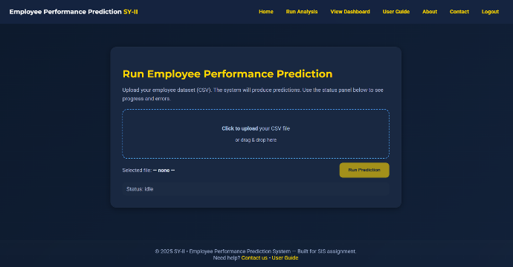
Figure 2: User Upload CSV file Interface
The system is used by the users via a Web-based user interface, according to which the HR staff can post datasets on employee performance in CSV format. The interface is constructed with the help of HTML5, CSS3 and JavaScript which makes it very intuitive and responsive to the user. Simple client-side validation is utilized in order to validate the uploaded files and make sure that they are of the proper structure before being sent to the backend.

4.1.2 Machine Learning and Backend Layer
The FastAPI is used to implement the backend, which serves as an interface between the web interface and machine learning model. On uploading a CSV file, FastAPI accepts the information via a RESTful API endpoint and process:
- Data parsing and validation
- Preprocessing of features with Pandas.
- Prediction with the trained machine learning model.
- The application is then loaded into FastAPI with the trained XGBoost multi classes classification model and it is used to predict the performance of each employee. The prediction outputs are provided in a structured format (CSV/JSON) to be the input of the frontend dashboard.

4.1.3 Dashboard and Visualization Layer
The interactive dashboard, created with Plotly Dash, integrated with HTML, CSS, and JavaScript, is used to display the results of the prediction. This layer is concerned with data visualization and interaction with the user whereby the HR users can explore the insights as a result of the ML predictions.

4.2 Machine Learning Integration through FastAPI
The process of developing the web application with machine learning has a clear pipeline:
- Read Dataset: The user clicks on the Upload button and uploads a CSV file via the web interface that is directed to the FastAPI backend using an HTTP POST request.
- Data Preprocessing: The backend handles the data submitted by the user with Pandas and NumPy, with consistency to the processing steps performed on the data during model training (e.g. feature encoding and scaling).
- Model Inference: The FastAPI service loads the previously trained XGBoost model (serialized with joblib) and makes predictions of the data uploaded to it. All records of the employees are categorized into the performance category.
- Response and Data Storage: The results of the predictions are sent back to the front-end and stored temporarily to be visualized and downloaded in a CSV format. This allows real time updates on the dashboard and eliminates manual page updates.
In this way, the model of communication between the ML and the web interface will be smooth, which will guarantee efficient and reliable delivery of predictions.

4.3 Dashboard Design and Technical Tools
Dashboard is designed to give actionable information on HR decision-making using interactive visual analytics.

4.3.1 Dashboard Features
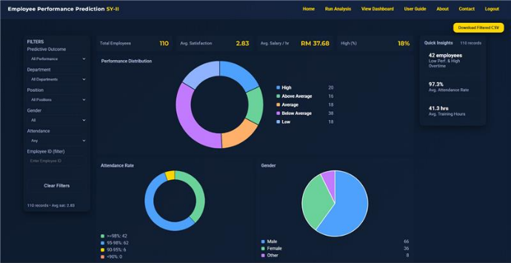
Figure 3: Dashboard
- Key Performance Indicators (KPIs): General indicators, including the average wage, hourly pay, performance distribution, and the number of employees.
- Performance Visualization: Bar charts and pie charts give the distribution of the predicted performance categories.
- Interactive Filtering: The data can be filtered by the users depending on department, performance class and other characteristics.
- csv Export Functionality: Results can be downloaded to be reported and documented.

4.3.2 Technical Tools Used
- Frontend Development: HTML5, CSS3, JavaScript.
- Dashboard Framework: Plotly Dash to interactive data visualization.
- Backend and API: FastAPI to provide ML predictions.
- Language Processing: Pandas, NumPy
- Visualization Library: Plotly (Bar charts, Pie charts, KPI indicators)
Such a combination of tools guarantees the real-time interactivity, clear visualization, and a flawless integration between the web interface and machine learning backend.

5. Model Development and Evaluation

5.1 Justification of the Model Selection

5.1.1 Why XGBoost
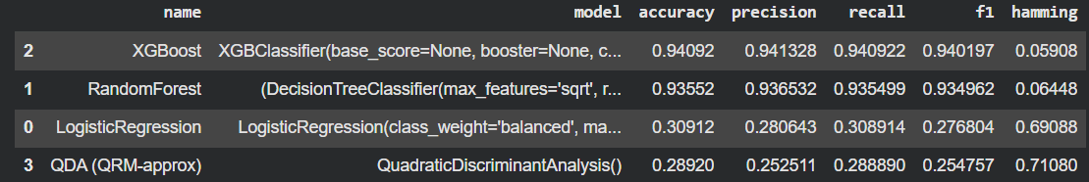
Figure 4: ML Models Comparison
XGBoost is chosen as the main model because it is shown to be effective in the structured tabular data that are widely applied in HR analytics. In contrast to linear models, XGBoost utilizes the power of ensemble decision trees to estimate complicated interactions across features. Its capacity to cope with missing values, minimize overfitting by regularization, as well as its high predictive accuracy, place its application in employee performance prediction tasks well (Zhu et al., 2022).

5.1.2 Processing Non-Linear SMART KPI Data
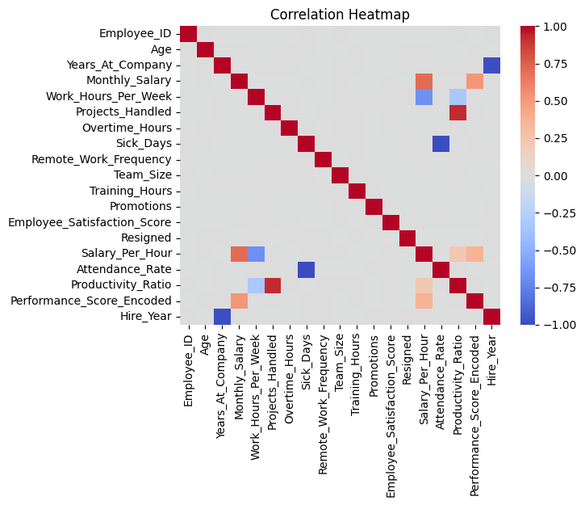
Figure 5: SMART KPIs Correlation Heatmap
The SMART KPI data is usually associated with weak linear correlations with the performance results and has strong non-linear patterns and includes interactions. XGBoost is very good at embedding such relationships because it recursively partitions the feature space that enables the model to learn conditional decision rules, which are dynamic in the real world.

5.2 Model Training Process
The data is split into training and testing set to test the generalization of the models. The model is fitted using the training set and the model is tested using test set which is unseen data used to determine the performance of the model.
Hyperparameter tuning is done to determine the best set of model parameters. The learning rate, maximum tree depth, and the number of estimators are adjusted to balance between model complexity and predictive performance.
Cross-validation is utilized in order to evaluate the stability of models on more than one data split. This reduces the variation in the performance estimate and makes predictive ability of the model not reliant on one train-test set up.

5.3 Model Evaluation Metrics
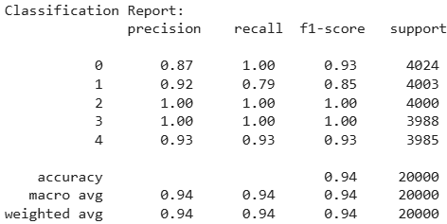
Figure 6: XGBoost Classification Report
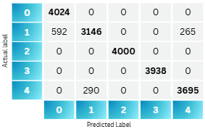
Figure 7: XGBoost Confusion Matrix
The XGBoost multi-class classification model performance proves to be at a high degree of predictive accuracy and robustness when used to assess the employee performance based on SMART KPI indicators. The findings of the confusion matrix show that the overall strategy of the model in the classification of all the employees into the five levels of performance have a classification accuracy of 94.41 percent, which proves that this model is very effective. Misclassifications are few and in most cases, occur among the performance categories that are adjacent (such as between Above Average and Average), which is the case with ordinal performance assessment problems. Notably, there are minimal or no errors in extremely misclassification like reporting as a High performer when he/she is actually a Low performer. This would imply that the model maintains the logical consistency and reliability in prediction, which is important in the HR decision-making situations.
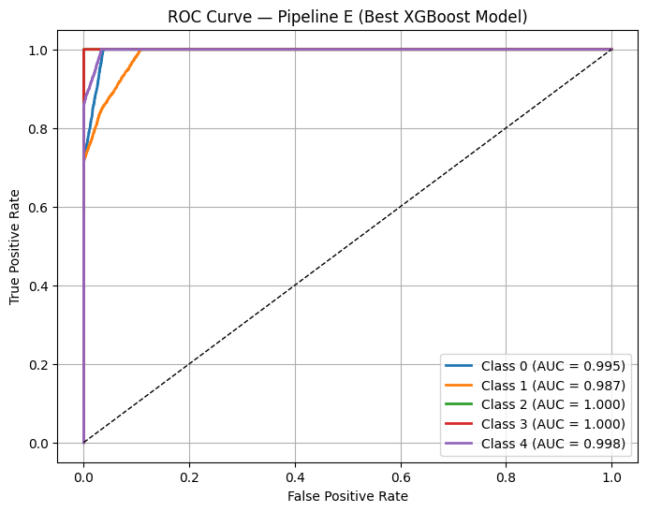
Figure 8: XGBoost ROC-AUC Performance
The discriminative ability of the model is strengthened through further testing with the help of multi-class ROC AUC analysis. The values of the Area Under the Curve (AUC) of each performance class are also very high; the values of Low (0.9946) and Below Average (0.9869) are superbly segregated as compared to the rest of the classes. It is important to note that both the Average and Above Average classes have an AUC of 1.0000, and the High performance class has an AUC of 0.9976. These findings suggest that the model is very sensitive in terms of differentiating between various levels of employee performance, including the situations when the limits of classes in real life situations can be overlapping. This type of performance demonstrates how XGBoost is applicable to non-linear, complicated HR data.
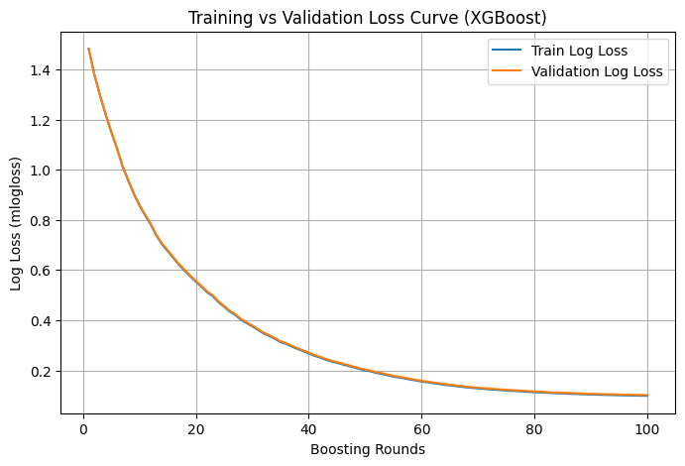
Figure 9: XGBoost Training vs Validation Loss Curve
Besides metrics of classification, model stability was evaluated by examining the training and validation loss as a function of boosting round. The findings indicate that the training loss as well as the validation loss steadily declines with an increase in the boosting iterations. What is important is that the two curves have a high overlap during the training process, which means that the model has a high balance between learning capacity and generalization. Such a behavior is an affirmation of the lack of overfitting (when the training performance is good but the validation performance is low) and underfitting (when the model is unable to capture underlying patterns). Therefore, XGBoost model exhibits consistent learning behavior and consistent performance in cases where it is used on unseen data.
In general, the results of the evaluation justify the usefulness of the developed machine learning method. High accuracy, excellent ROC-AUC scores, and minimal critical misclassifications, and stable training dynamics prove that the model can be effectively used in the deployment of the SmartAppraise AI system to facilitate objective and data-driven employee performance appraisal.

5.4 System Integration and Discussion
By combining the XGBoost model with FastAPI and an interactive dashboard, the prediction system can be modified into a decision-support platform as a whole. The system allows the HR personnel to:
- Deterministic performance trends.
- Make employee appraisal less subjective.
- Become HR data-driven.
In general, the SmartAppraise AI system manages to combine machine learning, web technologies, and dashboards into one platform to predict and analyze employee performance.

6. ESG and Sustainable Impact

6.1 Environmental (E)
On the environmental level, the system promotes sustainability in terms of its workforce planning based on data. The ability to better analyze the patterns of employee performance will allow organizations to better utilize their workforce, minimize unnecessary overtime, and enhance productivity planning. This reduces operational inefficiencies that have the effects of consuming too many resources. Moreover, the process of performance appraisal is digitalized through a web-based platform, which minimizes the use of paper-based appraisals and manual reporting and helps to decrease expenses on material consumption and make the HR workflow more environmentally responsible.

6.2 Social (S)
The SmartAppraise AI system has social sustainability as its strength. Machine learning is also able to provide fairer and more objective performance appraisal by basing the performance appraisal on SMART KPI standardized data and not on the human judgment alone. This minimizes the prejudice based on individual perceptions, favoritism, or uneven appraisal norms. With the system labeling all employees using a consistent multi-class classification model, it will encourage equity and inclusiveness in HR practices that include promotions, training assignment, including performance improvement planning. Consequently, this leads to a clearer and fair evaluation experience among the employees that has the potential to boost the trust levels, employee motivation and general morale at the workplace.

6.3 Governance (G)
On the aspect of governance, the system increases accountability and transparency in HR analytics. Interactive dashboards are used to clearly communicate the performance measurements, prediction results, and summarized insights and give stakeholders the ability to trace decisions to measurable indicators. FastAPI as a backend service can be used to ensure that the logic of prediction is centralized, standardized and auditable. This assists in responsible governing as it allows organizations to review, justify and document their HR decisions, basing them on evidence-based data and enhancing compliance and internal control strategies.

6.4. Conformity to United Nations Sustainable Development Goals (UN SDGs)
The SmartAppraise AI system is in line with a number of United Nations Sustainable Development Goals. It specifically contributes to the SDG 8 (Decent Work and Economic Growth) through fair performance assessment and informed development of workforce aimed at creating healthier and productive workplaces. Application of machine learning, FastAPI deployment, and interactive dashboards is an indicator of SDG 9 (Industry, Innovation and Infrastructure) since it shows the use of current digital infrastructure and innovation in managing an organization. Also, by minimizing bias and treating employees equally during performance appraisal, the system aims to achieve SDG 10 (Reduced Inequalities) and promote inclusive and unbiased HR practices.

7. Limitations and Future Enhancement
Although effective, the SmartAppraise AI system has a number of weaknesses, which provide potential future opportunities to improve it. The size and the diversity of the dataset with which the models trained is one of the major limitations. Higher and more varied data in terms of industries, occupation, and demographics are to enhance model generalization and strength. Also, though XGBoost model has good anticipatory power, its decision-making procedure may be complicated to explain. Explainability methods, e.g., SHAP values, can be used in the future to make work more transparent and trustworthy in model predictions.
The other area that can be improved is real-time data integration. Today, forecasts are created when CSV files are posted; it would be possible to introduce real-time HR systems or databases that will allow the continuous monitoring of performance and provide insights more immediately. Moreover, the increased number of SMART KPIs (e.g., leadership indicators, collaboration metrics, or project complexity) might offer a more comprehensive perspective on employee performance. These improvements would also make the system stronger in its practical applicability and strategy.

8. Conclusion
By implementing a machine learning-based data-driven approach to subjective and inefficient employee performance appraisal, this project aimed to help resolve the problem of weak appraisal and inconsistent performance evaluation. With the use of non-linear machine learning, namely, XGBoost, the system can successfully represent intricate correlations between SMART KPI indicators to provide valid multi-class predictions of the performance. The model applied to FastAPI and interactive dashboards allows the analysis, visualization, and decision-making processes of HR stakeholders with ease.
On the whole, the SmartAppraise AI system shows that a well-developed machine learning, in conjunction with modern web technologies, can have a significant impact on better HR analytics. In addition to enhancing the accuracy of appraisal, the system will bring about sustainable and ethical HR practices since it enhances fairness, transparency, and accountability. This paper reveals how smart and data-intensive tools can contribute to organizational performance and also long-term sustainability goals.

References
Bicudo de Castro, V. (2017). Unpacking the notion of subjectivity: Performance evaluation and supervisor discretion. The British Accounting Review, 49(6), 532–544. https://doi.org/10.1016/j.bar.2017.08.003
Bretz, R. D., Jr., Milkovich, G. T., & Read, W. (1992). The current state of performance appraisal research and practice: Concerns, directions, and implications. Journal of Management, 18(2), 321–352. https://doi.org/10.1177/014920639201800206
Hulugh, T., & Emmanuel, B. (2024). Agile project management in developing business-centric information systems. International Journal of Research Publication and Reviews, 5(11), 5083–5098. https://doi.org/10.55248/gengpi.5.1124.3332
Kang, S. W., & Park, C. H. (2025). Effective federated XGBoost learning for multi-class classification in Non-IID environments. The Journal of Supercomputing, 81(6). https://doi.org/10.1007/s11227-025-07245-3
Kunz, J. (2015). Objectivity and subjectivity in performance evaluation and autonomous motivation: An exploratory study. Management Accounting Research, 27, 27–46. https://doi.org/10.1016/j.mar.2015.01.003
Muhammad Fawwaz Narendra. (2025). Forecasting manpower planning using the CRISP-DM method and machine learning algorithm: A case study of tiki jalur nugraha ekakurir (JNE) company. Journal of Information Systems Engineering and Management, 10(19s), 371–378. https://doi.org/10.52783/jisem.v10i19s.3040
Shi, B., & Van Triest, S. (2025). What determines managers’ use of subjective performance information? Accounting and Business Research, 1–25. https://doi.org/10.1080/00014788.2025.2521488
Shields, J., Kim, S., Chhetri, A., Stanton, P., & Nankervis, A. (2023). Traditional, transitional and new performance management practices in Australian organisations: Incidence, coverage and perceived effectiveness. Asia Pacific Journal of Human Resources, 61(3), 554–581. https://doi.org/10.1111/1744-7941.12372
Tran, T., & Järvinen, J. (2022). Understanding the concept of subjectivity in performance evaluation and its effects on perceived procedural justice across contexts. Accounting &amp; Finance, 62(3), 4079–4108. https://doi.org/10.1111/acfi.12916
Waheed, A., Abbas, Q., & Malik, O. (2018). ‘Perceptions of performance appraisal quality’ and employee innovative behavior: Do psychological empowerment and ‘perceptions of HRM system strength’ matter? Behavioral Sciences, 8(12), 114. https://doi.org/10.3390/bs8120114
Wick, S. (2021). Subjectivity in performance evaluations: A review of the literature*. Accounting Perspectives, 20(4), 653–685. https://doi.org/10.1111/1911-3838.12273
Woerkom, M. van, & Kroon, B. (2020). The effect of strengths-based performance appraisal on perceived supervisor support and the motivation to improve performance. Frontiers in Psychology, 11. https://doi.org/10.3389/fpsyg.2020.01883
Zhu, W., Shen, S., & Zhang, Z. (2022). Improved multiclassification of schizophrenia based on xgboost and information fusion for small datasets. Computational and Mathematical Methods in Medicine, 2022, 1581958. https://doi.org/10.1155/2022/1581958

